**TASK 4.2P**

Code for finding a document:

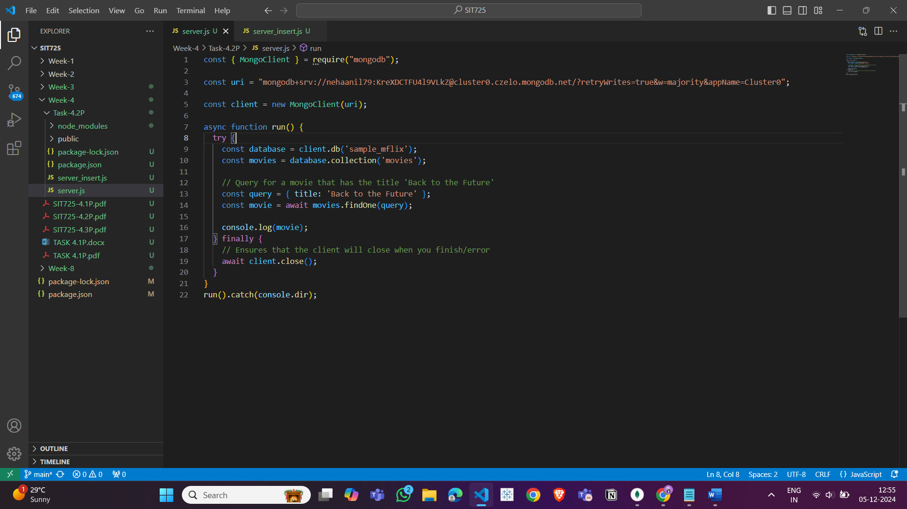

Output:

Code for insert a document:

Output:

